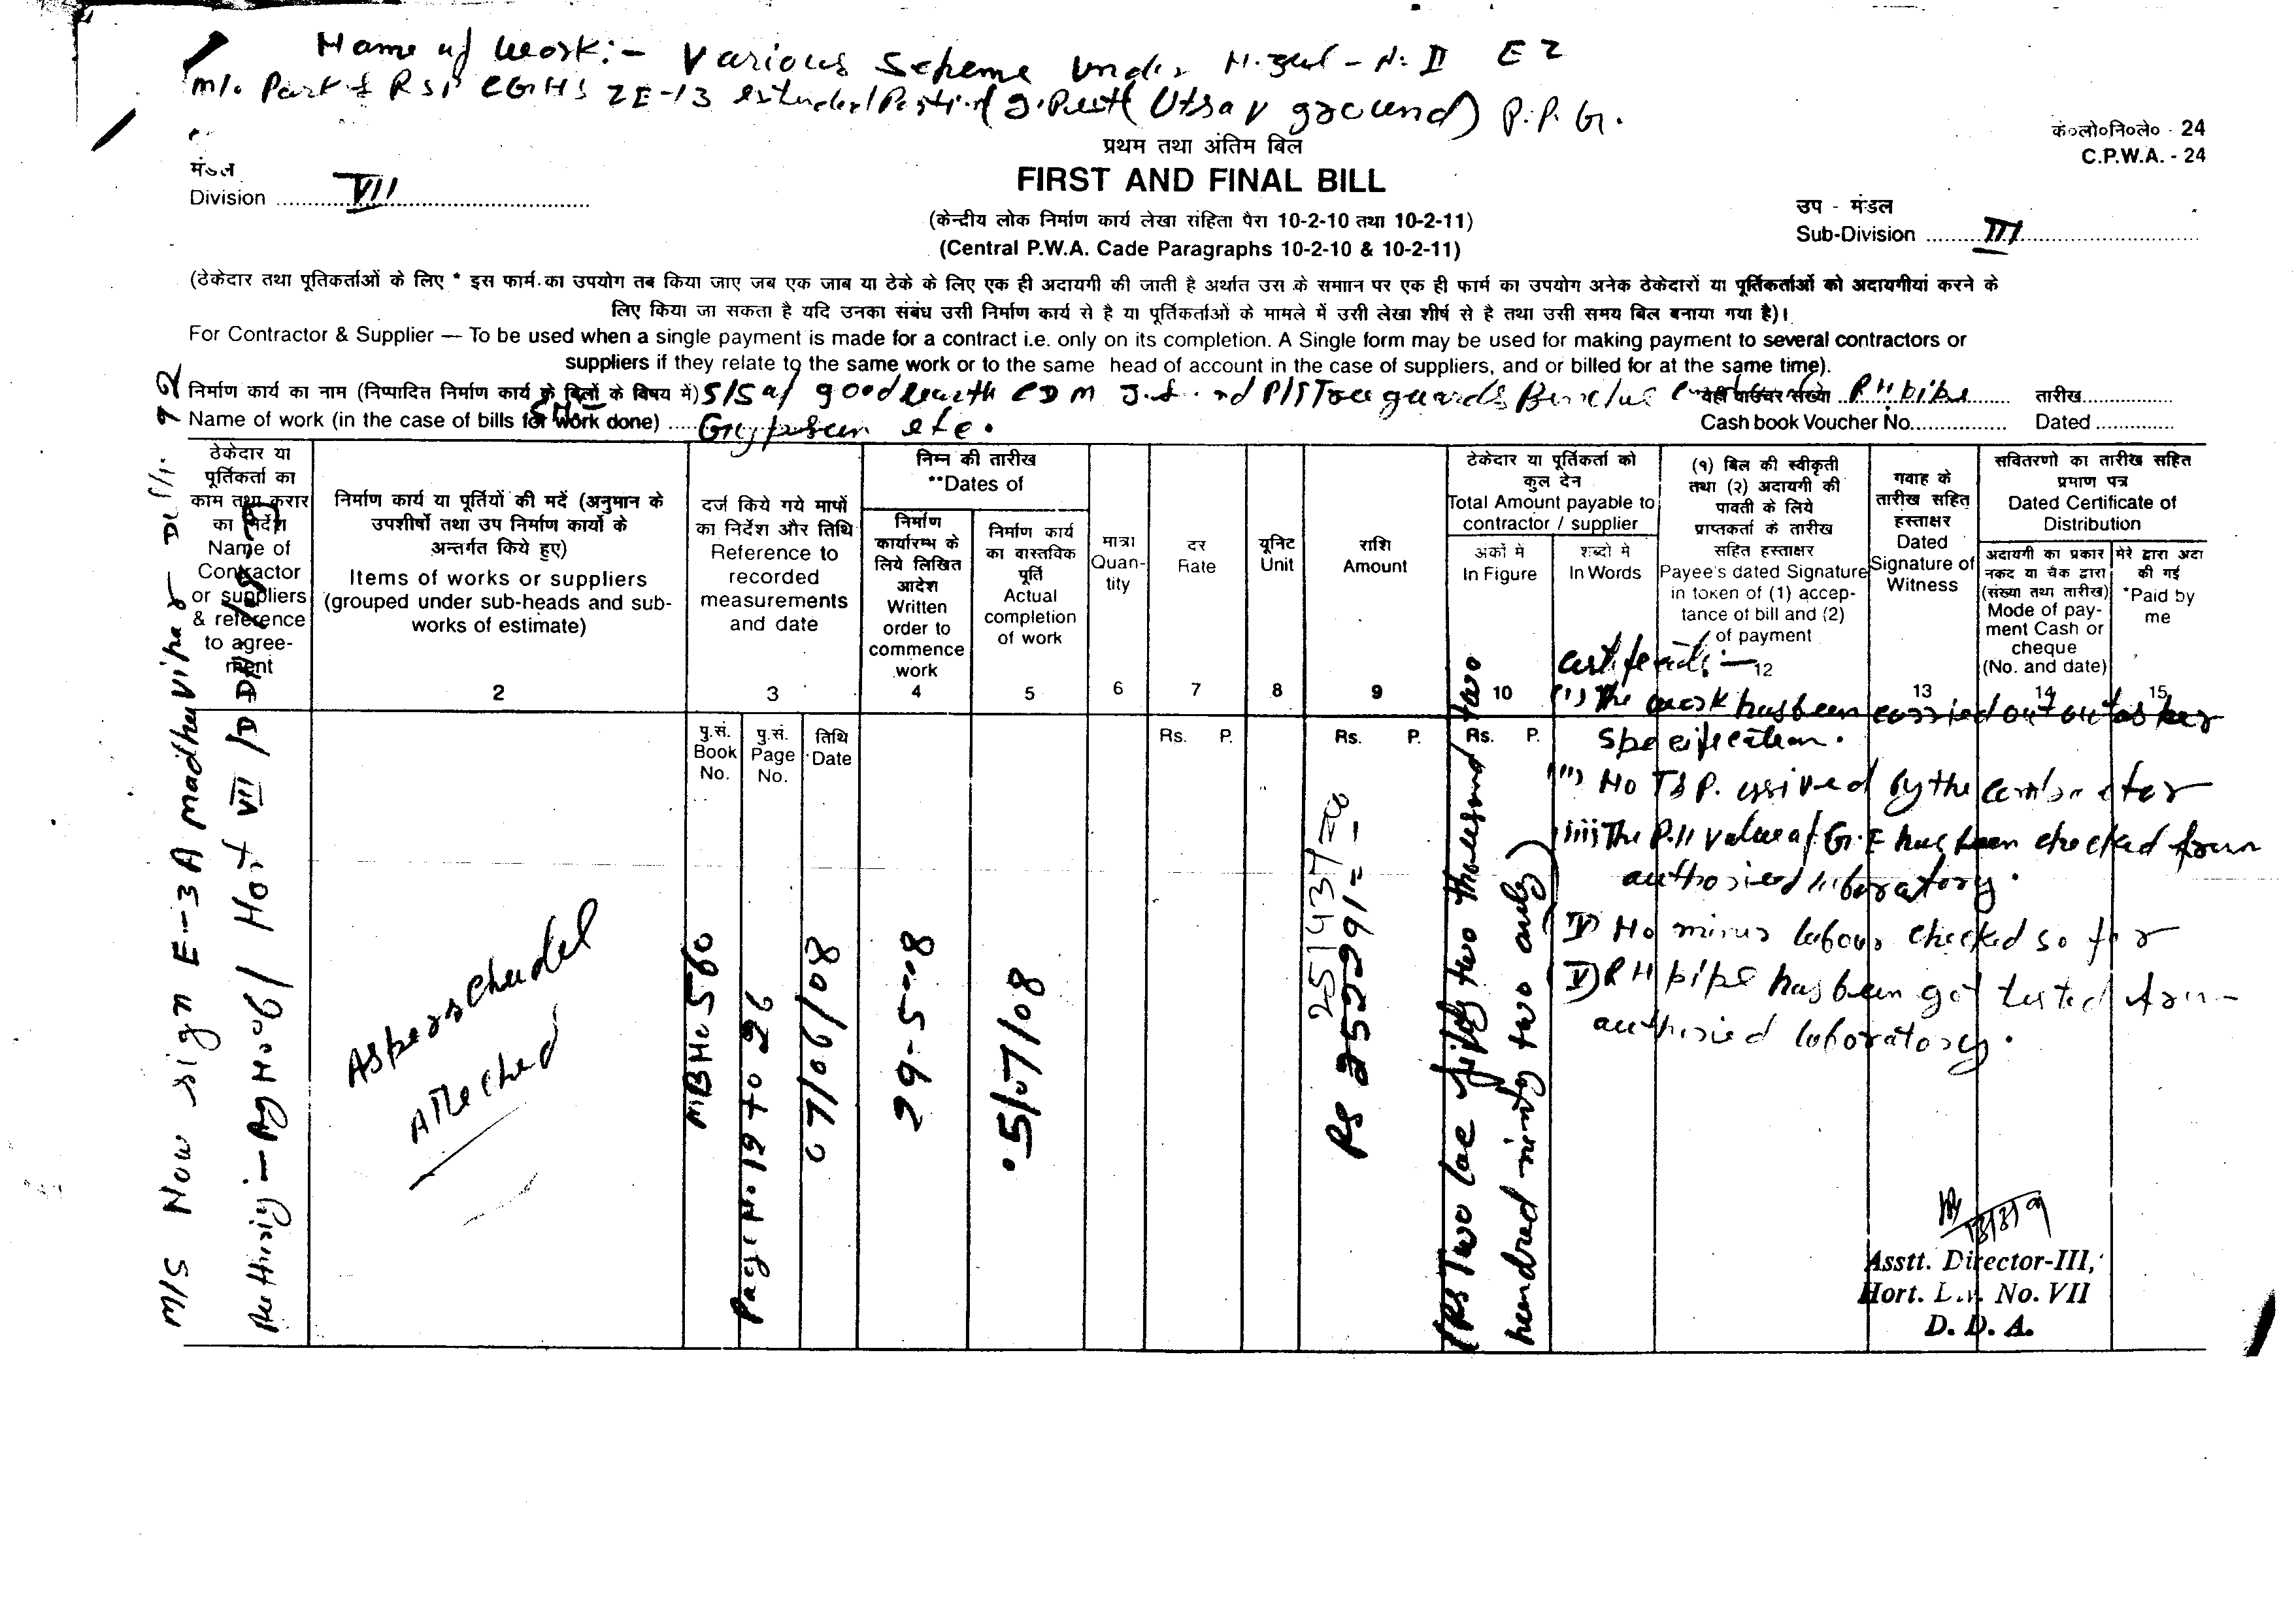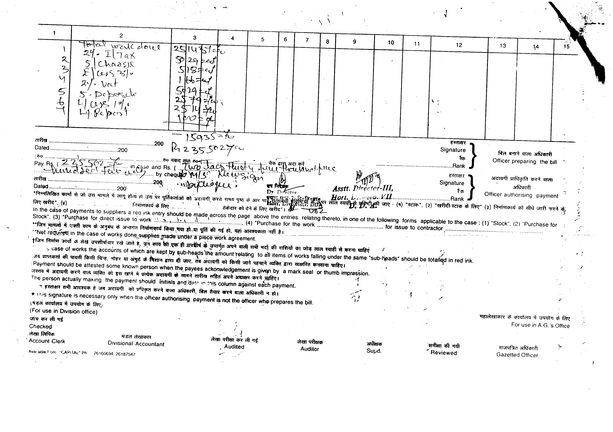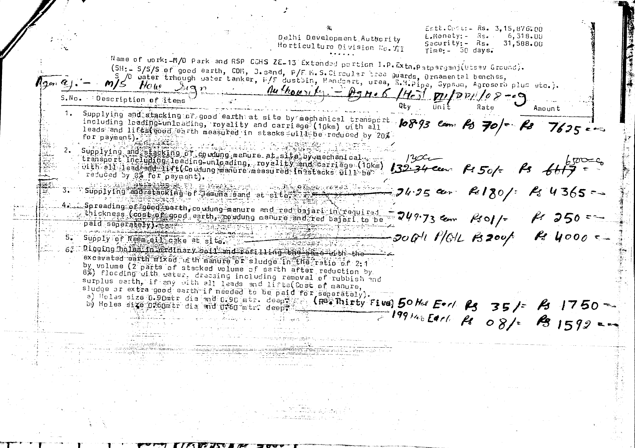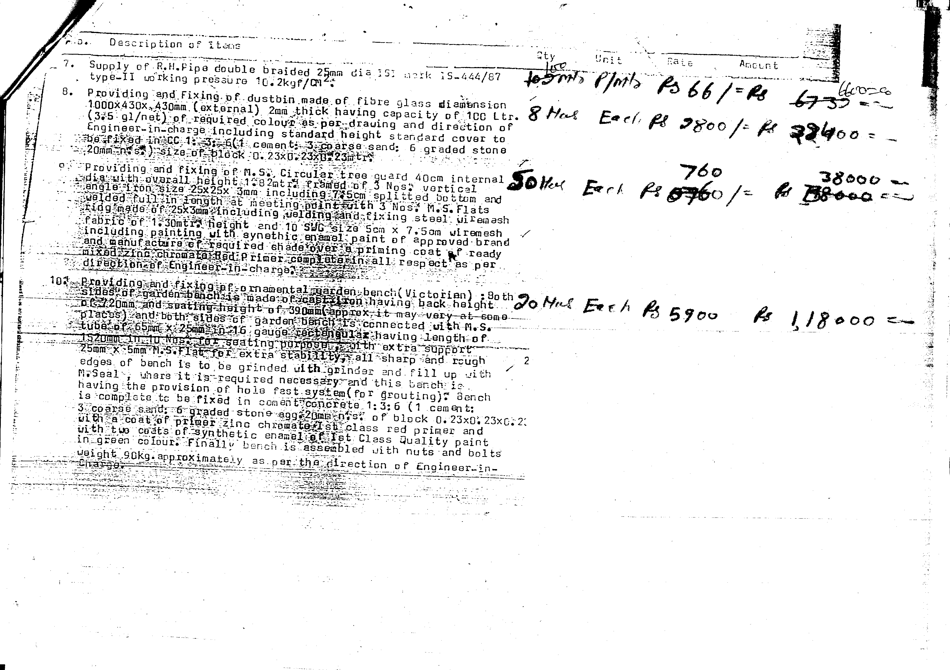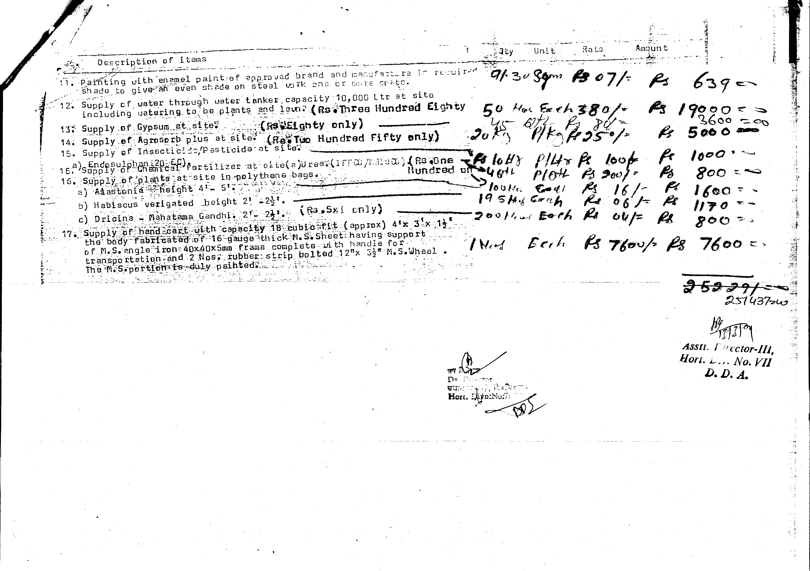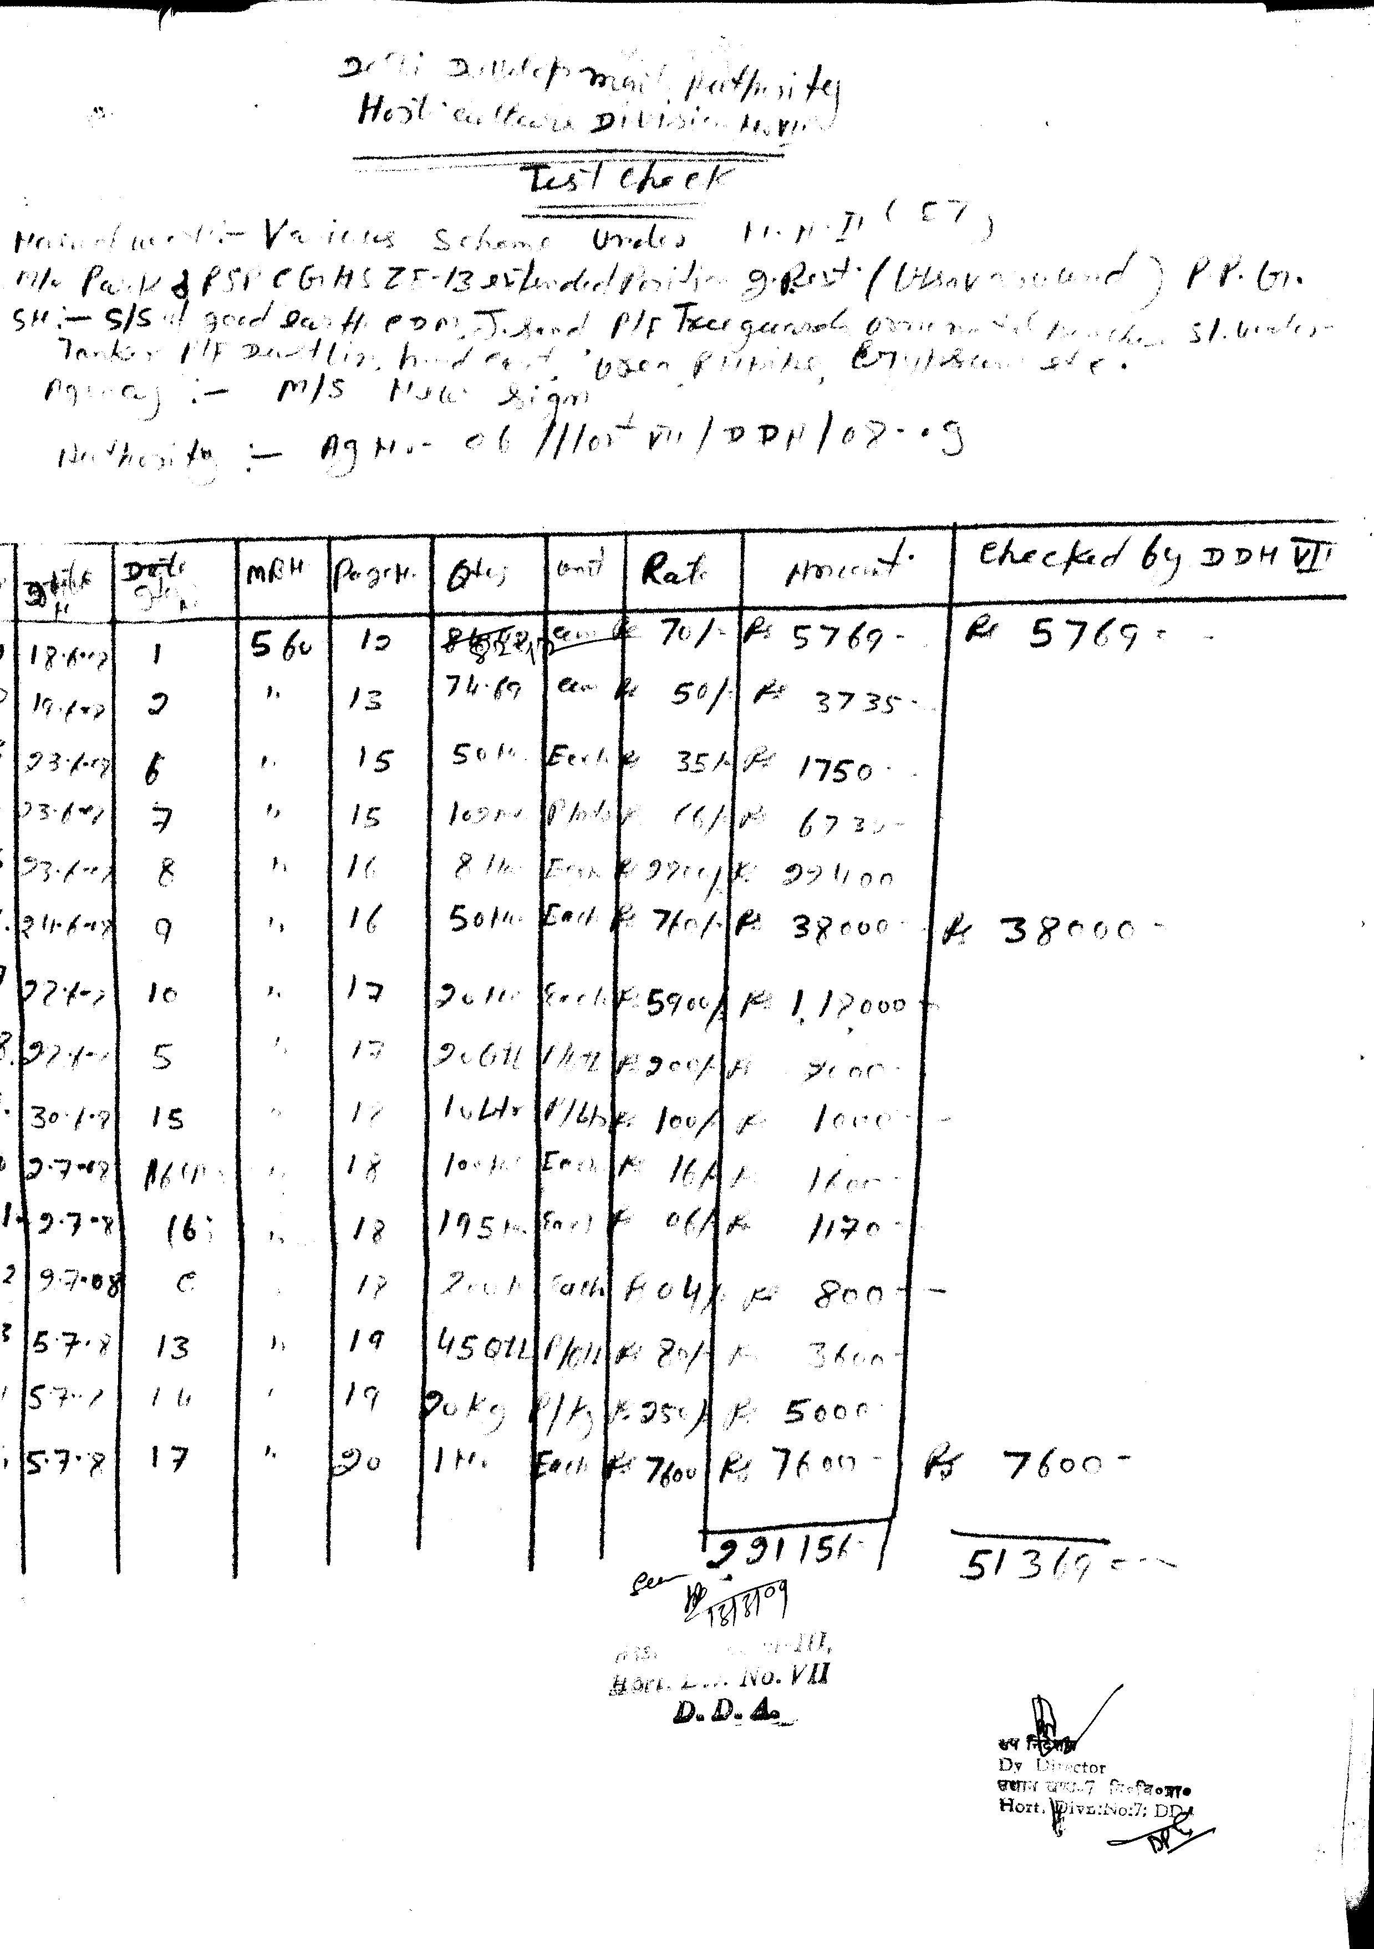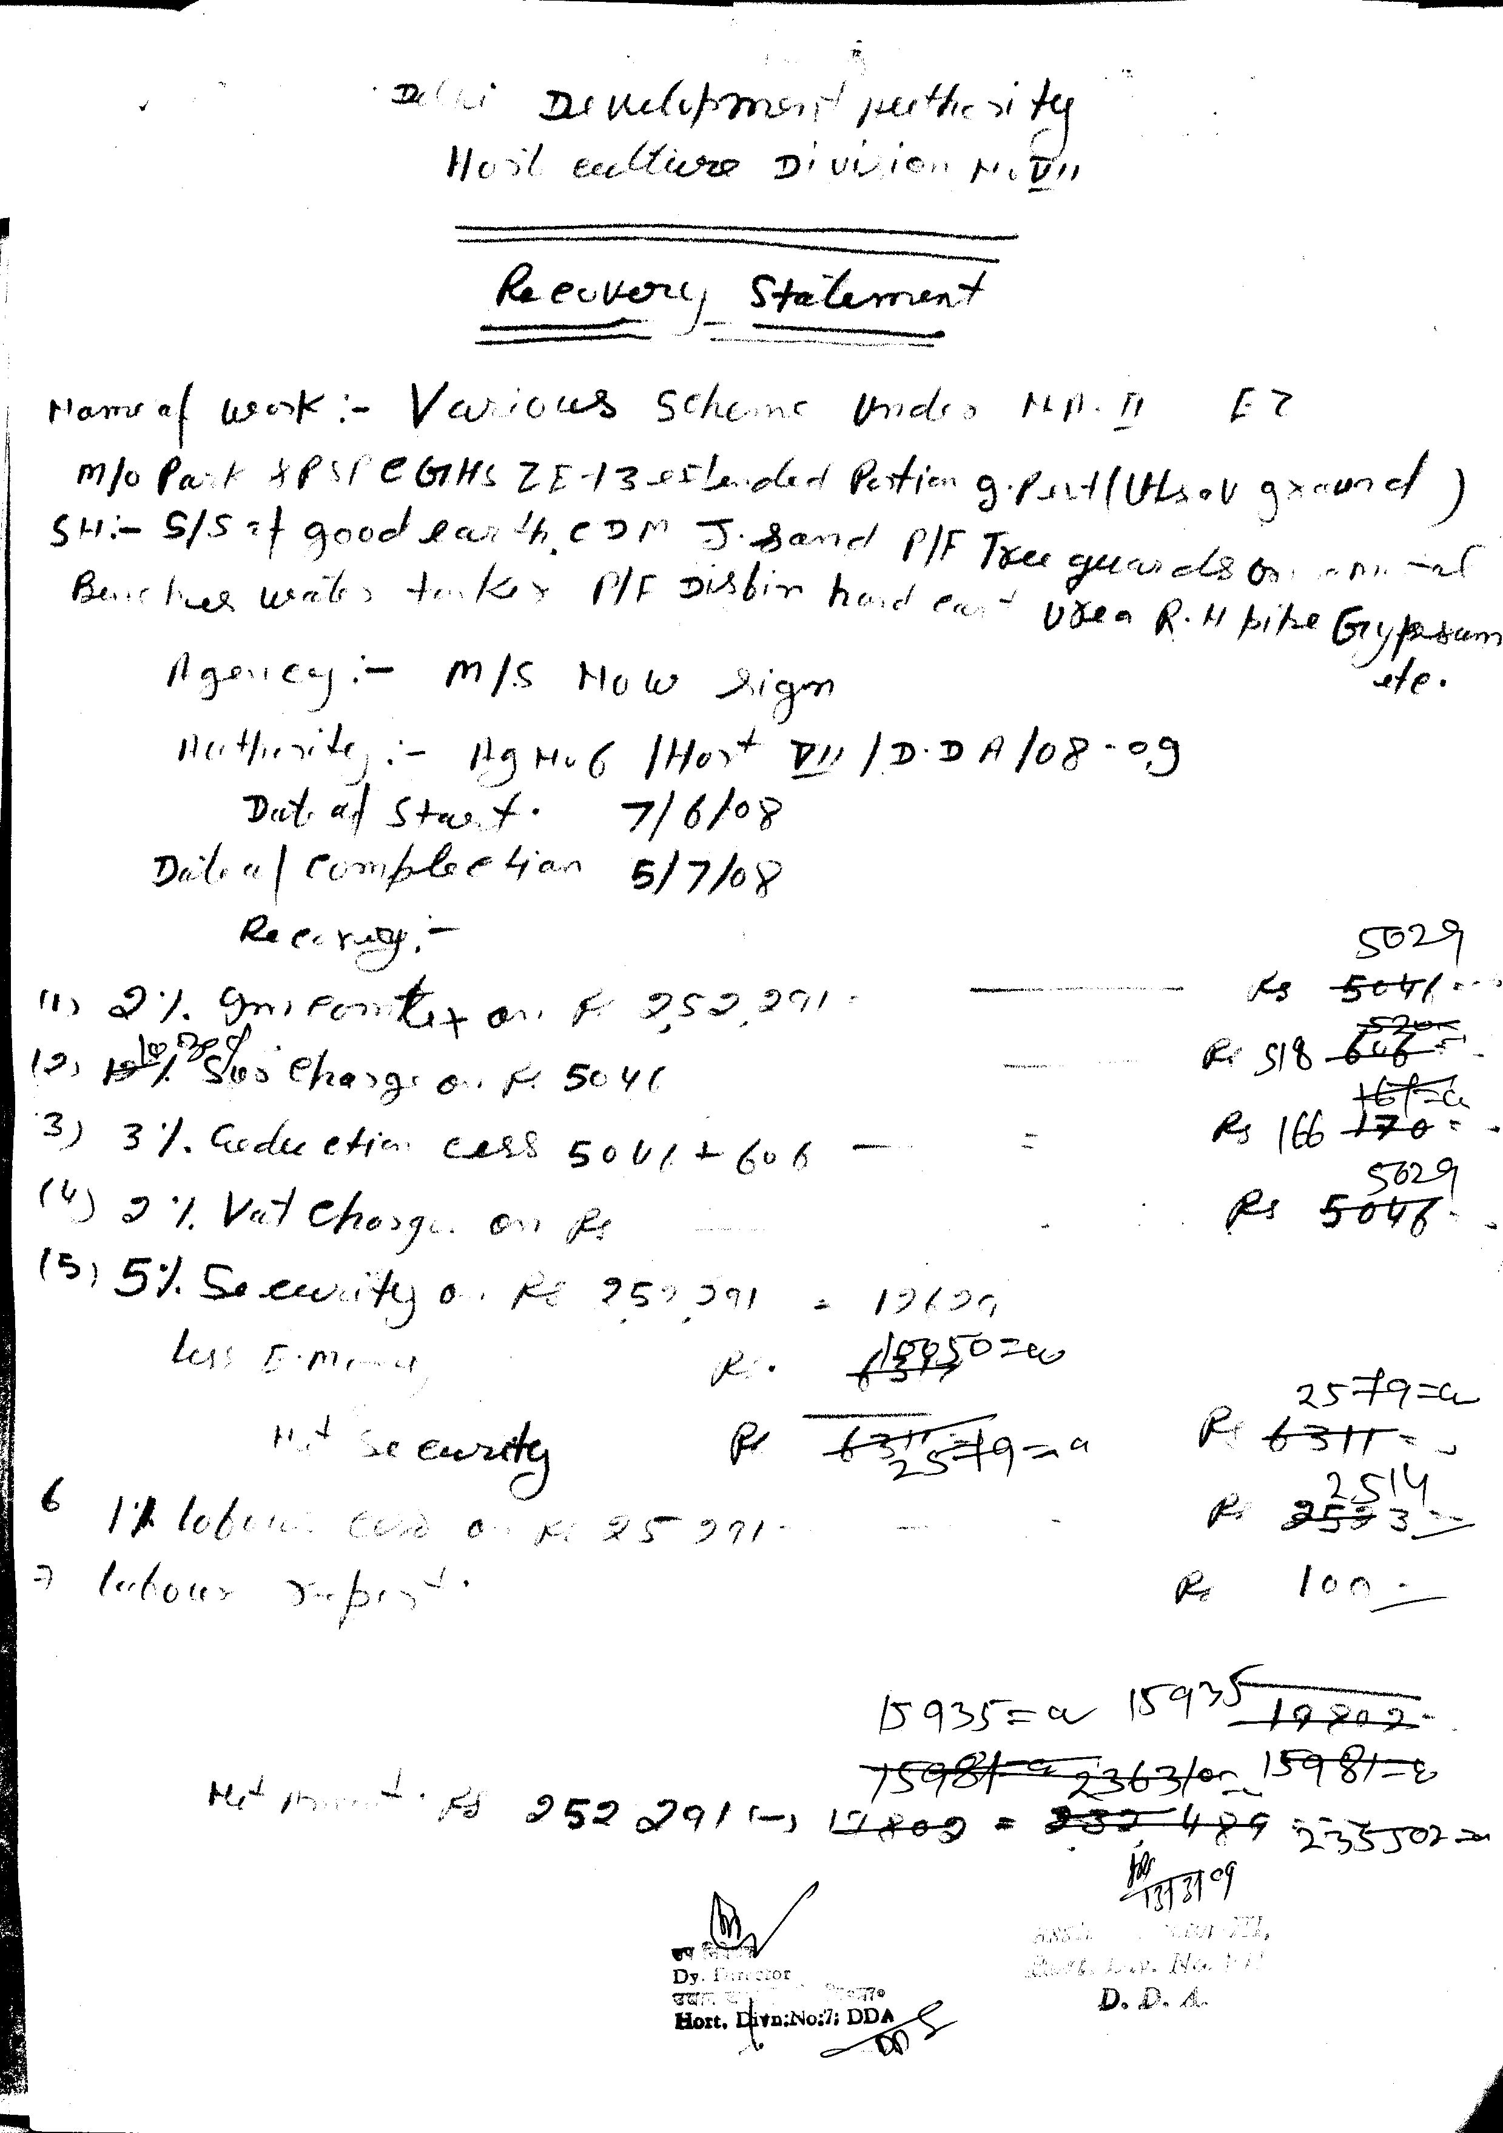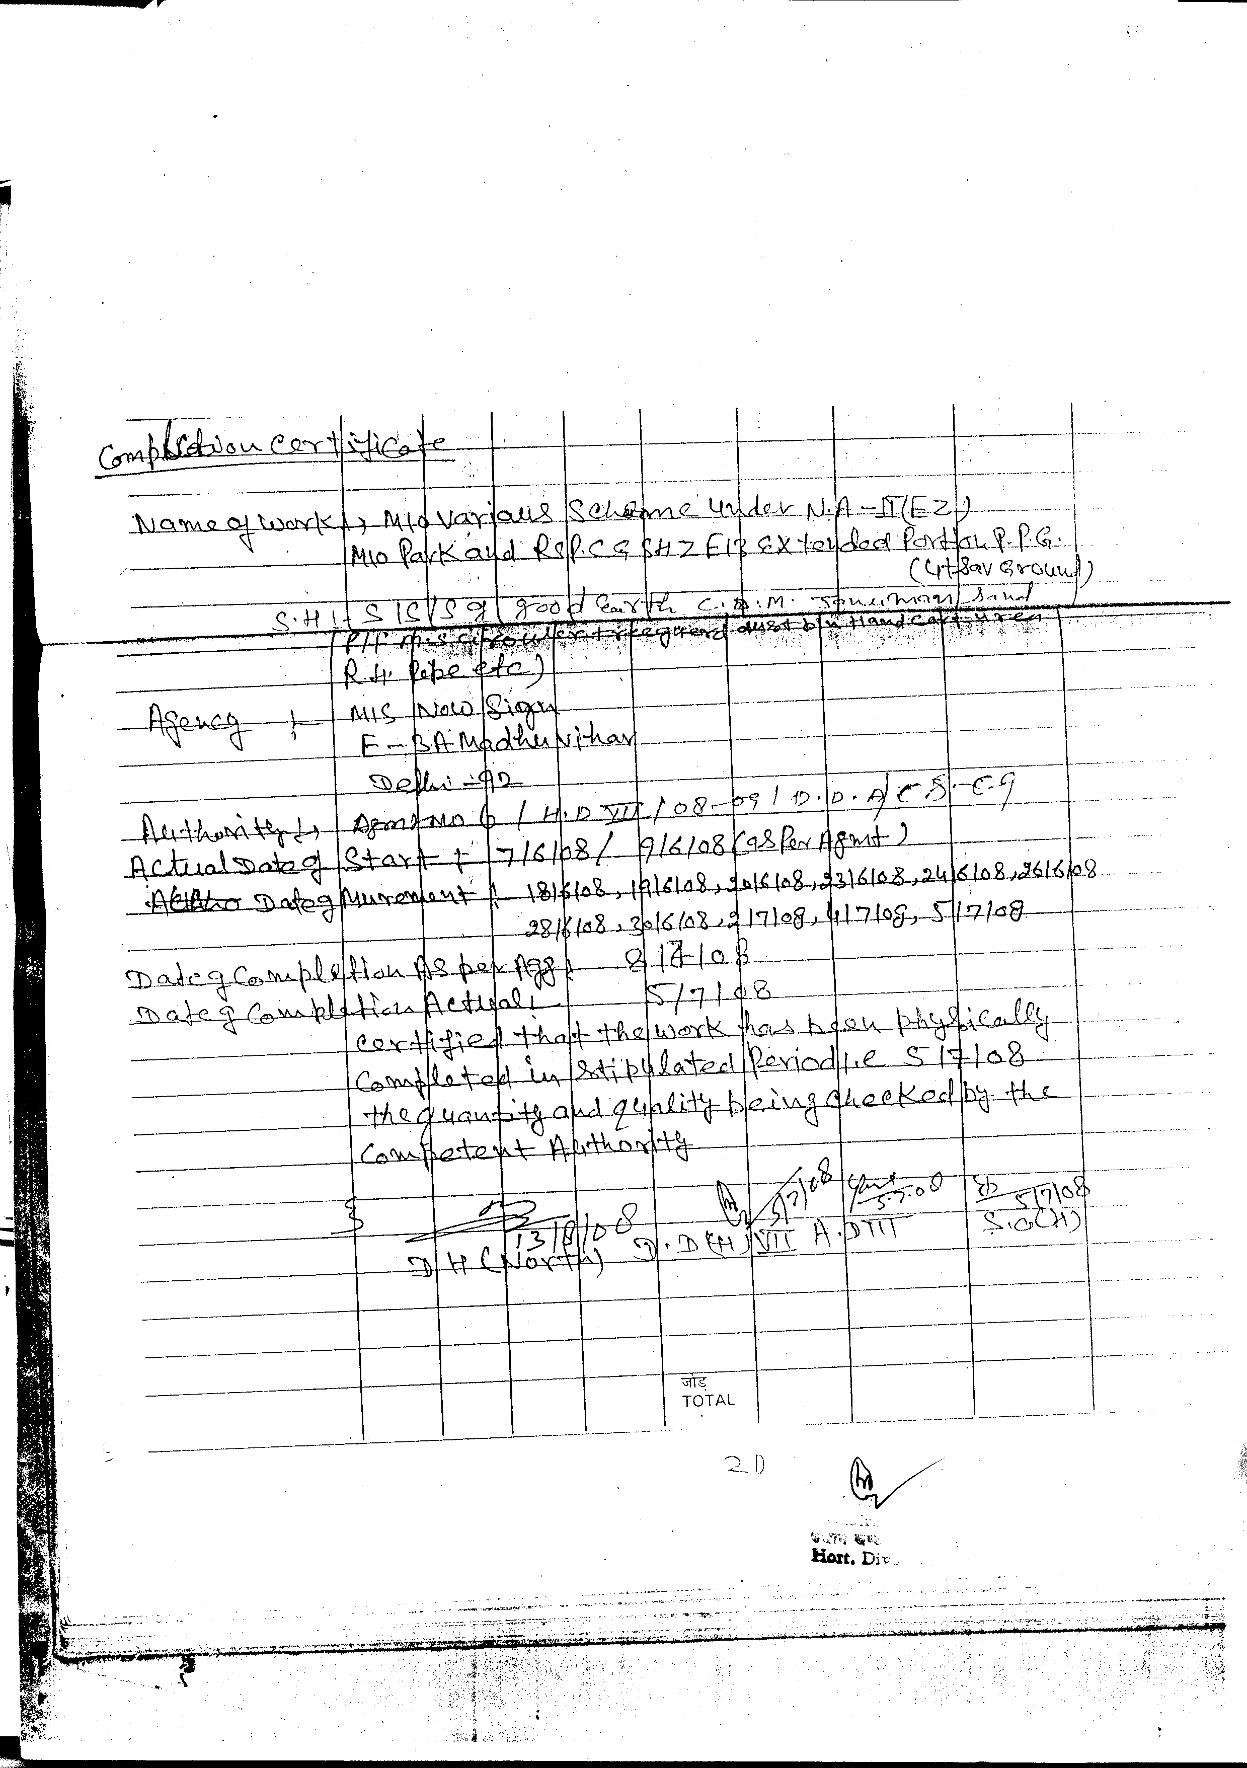

me Nishi Gupta
Nishi
Nishi
Name Nishi Gu
Name Nishi Gupta
Name Nishi GuptaName Nishi Gupta

Name Nishi Gupta

Gupta
Nishi
Happy New Year
Name Nishi Gupta
Name Nishi Gupta
Name Nishi Gupta
Name Nishi Gupta
Name Nishi Gupta

Name Nishi Gupta
Name Nishi Gupta
Name Nishi Gupta
Name Nishi Gupta
Name Nishi Gupta
Name Nishi Gupta
Name Nishi Gupta
Name Nishi Gupta
Name Nishi Gupta
Name Nishi Gupta
Name Nishi Gupta
Name Nishi Gupta
Name Nishi Gupta
Name Nishi Gupta
Name Nishi Gupta
Name Nishi Gupta
Name Nishi Gupta
Name Nishi Gupta
Name Nishi Gupta
Name Nishi Gupta
Name Nishi Gupta
Name Nishi Gupta
Name Nishi Gupta
Name Nishi Gupta
Name Nishi Gupta

