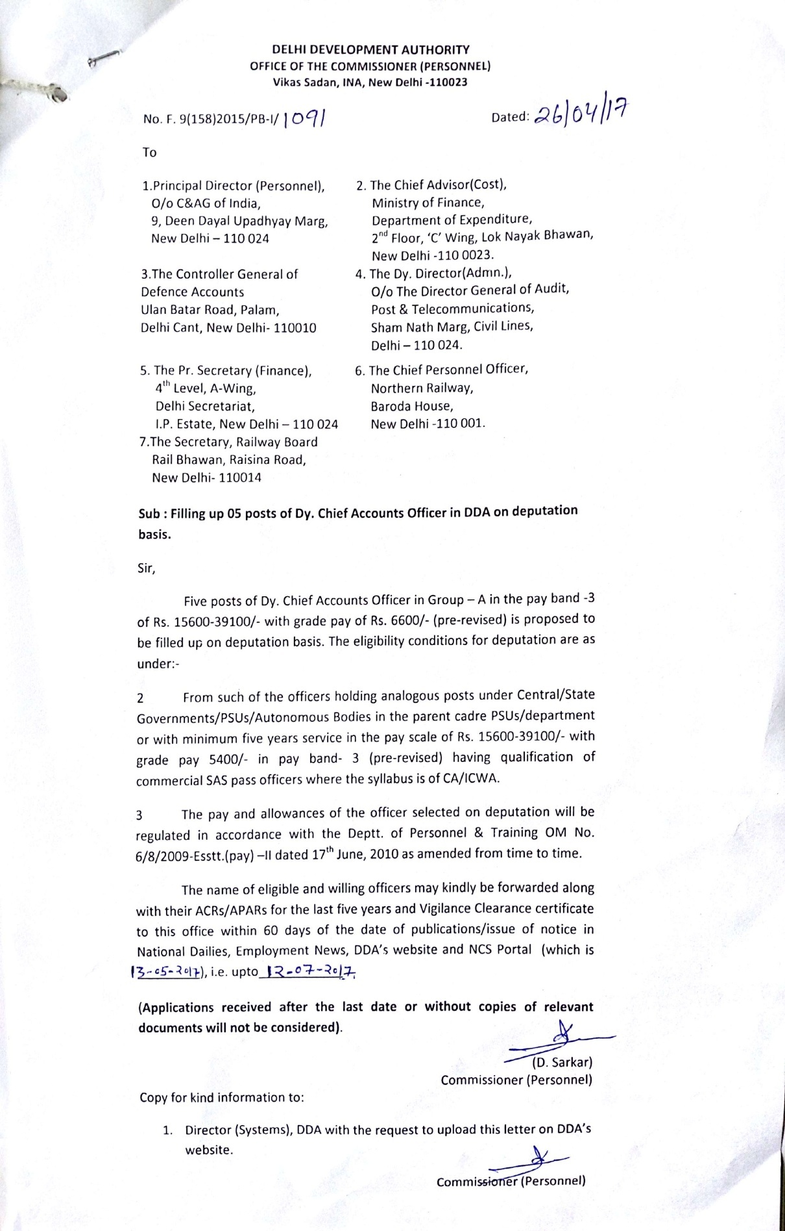

**Bio-data /Curriculum Vitae (CV) proforma for submission by the candidate for appointment by deputation**

|  |  |  |  |  |  |  |  |  |  |  |  |  |  |  |  |  |
| --- | --- | --- | --- | --- | --- | --- | --- | --- | --- | --- | --- | --- | --- | --- | --- | --- |
| 1. | Name and address  (in Block Letters) | | | | | | |  | | | | | | | | |
| 2. | Date of Birth | | | | | | |  | | | | | | | | |
| 3. | i)Date of entry into service | | | | | | |  | | | | | | | | |
| ii)Date of retirement under Central /State government Rules | | | | | | |  | | | | | | | | |
| 4. |  | | | | | | |  | | | | | | | | |
| 5. |  | | | | | | |  | | | | | | | | |
| Qualifications / experience possessed by the officer | | | | | | | | |
| Essential | | | | | | | | |
| A)Qualification:- | | | | | | | | |
| B) Experience | | | | | | | | |
| Desirable | | | | | | | | |
| A)Qualification:- | | | | | | | | |
| B) Experience | | | | | | | | |
| 6. | Please state clearly whether in the light of entries made by you above, you meet the requisite Essential Qualifications and work experience of the post. | | | | | | | | |  | | | | | | |
| 7. | Details of employment, in chronological order. Enclose a separate sheet duly authenticated by your signature, if the space below is insufficient. | | | | | | | | | | | | | | | |
|  | Office / Institution | | | Post held on regular basis | | | From | | | | to | | *Pay Band and Grade Pay / Pay Scale of the post held on regular basis | | | Nature of Duties (in detail) highlighting experience required for the post applied for |
|  |  | | |  | | |  | | | |  | |  | | |  |
|  | *Important: Pay-Band and Grade Pay granted under ACP/MACP are personal to the officer and therefore, should not be mentioned. Only Pay Band and Grade Pay / Pay / Pay Scale of the post held on regular basis to be mentioned. Details of ACP / MACP with present Pay Band and Grade Pay where such benefits have been drawn by the Candidate, may be indicated as below: | | | | | | | | | | | | | | | |
|  | Office/Institution | | | | | | Pay, Pay Band, and Grade Pay drawn under ACP / MACP Scheme | | | | | | from | | | to |
|  |  | | | | | |  | | | | | |  | | |  |
| 8. | | | Nature of present employment i.e. Ad-hoc or Temporary or Quasi-Permanent or Permanent | | | | | |  | | | | | | | |
| 9. | | | In case the present employment is held on deputation / contract basis, please state- | | | | | |  | | | | | | | |
|  | | | a) The date of initial appointment | | b)Period of appointment on deputation / contract | | | | c)Name of the parent office / organization to which the applicant belongs. | | | | | | d) Name of the post and Pay of the post held in substantive capacity in the parent organization. | |
|  | | |  | |  | | | |  | | | | | |  | |
| 9.1 | | | Note:- In case of officers already on deputation, the applications of such officers should be forwarded by the parent cadre / Department along with Cadre Clearance , Vigilance Clearance and Integrity Certificate. | | | | | | | | | | | |  | |
| 9.2 | | | Note: Information under Column 9(c) & (d) above must be given in all cases where a person is holding a post on deputation outside the cadre/ organization but still maintaining a lien in his parent cadre / organization. | | | | | | | | | | | |  | |
| 10. | | | If the post held on Deputation in the past by the applicant, date of return from the last deputation and other details. | | | | | | | | |  | | | | |
| 11. | | Additional details about present employment:  Please state whether working under (indicate the name of your employer against the relevant column:   1. Central Government 2. State Government 3. Autonomous Organization 4. Government Undertaking 5. Universities 6. Others | | | | | | | | | |  | | | | |
| 12. | | | Please state whether you are working in the same Department and are in the feeder grade or feeder to feeder grade. | | | | | | | | |  | | | | |
| 13. | | | Are you in Revised Scale of Pay ? If yes, give the date from which the revision took place and also indicate the pre-revised scale | | | | | | | | |  | | | | |
| 14 | | | Total emoluments per month now drawn | | | | | | | | | | | | | |
|  | | | Basic Pay in the PB | | Grade Pay | | | | | Total Emoluments | | | | | | |
|  | | |  | |  | | | | |  | | | | | | |
| 15. | In case the applicant belongs to an Organization which is not following the Central government Pay –scales, the latest salary slip issued by the Organization showing the following details may be enclosed. | | | | | | | | | | | | | | | |
|  | Pasic Pay with Scale of Pay and rate of increment | | | | | Dearness Pay / interim relief / other Allowances etc. (with break-up details) | | | | | | | | Total Emoluments | | |
|  |  | | | | |  | | | | | | | |  | | |
| 16A. | Additional information, if any, relevant to the post you applied for in support of your suitability for the post.  (This among other things may provide information with regard to **(i)** additional academic qualifications **(ii)**professional training and **(iii)**work experience over and above prescribed in the Vacancy Circular/Advertisement). | | | | | | | | |  | | | | | | |
| 16B | **Achievements:**  The candidates are requeste4d to indicate information with regard to;   1. Research publications and reports and special projects   (ii)Awards / Scholarships / Official Appreciation  (iii)Affiliation with the professional bodies / institutions / societies and;  (iv) Patents registered in own name or achieved for the organization  (v)Any research / innovative measure involving official recognition  (vi) any other information.  **(Note: Enclose a separate sheet if the space is insufficient)** | | | | | | | | |  | | | | | | |
| 17. | Whether belongs to SC/ST | | | | | | | | |  | | | | | | |

I have carefully gone through the vacancy circular/advertisement and I am well aware that the information furnished in the Curriculum Vitae duly supported by the documents in respect of Essential Qualification / Work Experience submitted by me will also be assessed by the Selection Committee at the time of selection for the post. The information / detail provided by me are correct and true to the best of my knowledge and no material fact having a bearing on my selection has been suppressed / withheld.

(Signature of the candidate)

Address__________________

Date__________________

**Certification by the Cadre Controlling Authority**

The information / details provided in the above application by the applicant are true and correct as per the facts available on records. He / she possesses educational qualifications and experience mentioned in the vacancy Circular. If selected, he / she will be relieved immediately.

2. Also certified that;

i) There is no vigilance or disciplinary case pending / contemplated against Sh. /Smt………………………………………………………………..

ii) His / Her integrity is certified.

iii) His / Her APARs for the last 5 years duly attested by an officer of the rank of Under Secretary of the Govt. of India or above are enclosed.

iv) No major / minor penalty has been imposed on him / her during the last 10 years  **OR**  A list of major / minor penalties imposed on him / her during the last 10 years is enclosed.(as the case may be)

Countersigned

------------------------------------------------------------

( Cadre Controlling Authority with Seal)